Name: Pushp Raj
Entry No: 2018PH10830
Name: Rishu Kumar
Entry No:2018PH10838
Assignment 1Part 1

In the first part of this assignment, we have to quantize image by using following algorithm.
*Uniform Quantization
*Popularity Algorithm
*Median Cut Algorithm
*FloydSteinberg Quantization

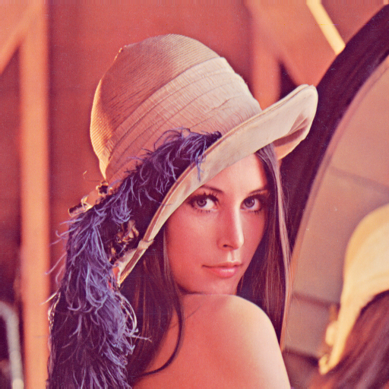
Demo Image: We have used Lenna Image of dimension 512*512*3.

Uniform Quantization:
In this type of quantization. We have to assign every
Page 1
color to one of unifromly distributed color map
if the color lies between kth and (k-1)th it can be assigned kth color
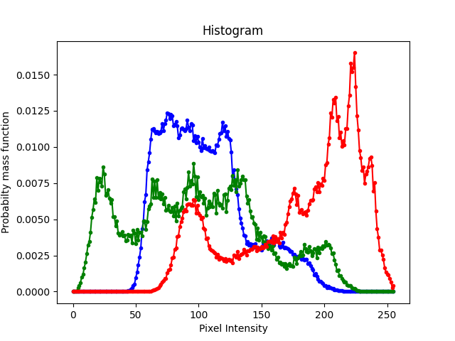
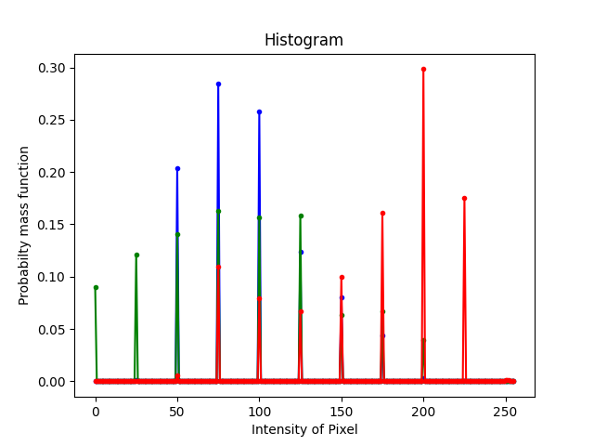

Histogram of Lenna image (original)
Histogram of Lenna image with uniform quantization

Pseudo code:
algorithm uniform(img, k) //k is quantization of color
interval=256/k
arr={0,interval, 2*interval, 3*interval..... k*interval}

for 0<=i<row
for 0=<j<column
if interval1<= img[i][j]<interval2:
img[i][j]=interval1

end
Time Complexity:
O(n^2*k)

Popularity algorithm:
This is similar to Uniform Quantization the only thing we have to do is find out the k^{th} most popular color by ploting probability mass function
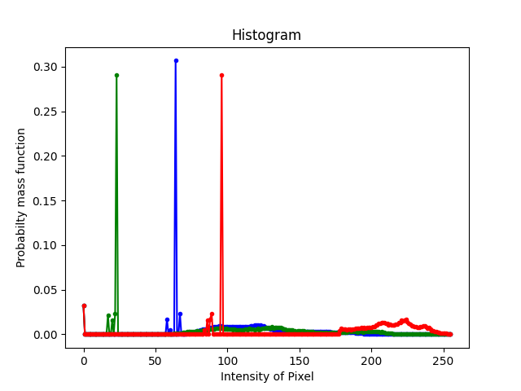

Pseudo code:
algorithm pupularAlgo(img,k)
arr=p(img,k) //this will give popular k values of color
for 0<=i<row
for 0=<j<column
if interval1<= img[i][j]<interval2:
img[i][j]=interval1
end
Time Complexity:
Page 2
O(n^2*k)

MedianCut Algorithm:
In this type of quantization we have to recursively divide the image
accroding to the median of thier color distribution. And assign every
section avg of their color distribution.
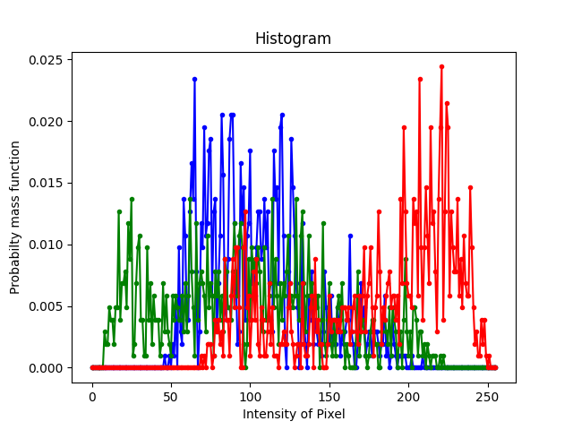

Pseudo Code:
Algorithm medianCut(img,k)
if k==0
color=mean(img.color)
for 0<=i<row
for 0<=j<column
img[i][j]=color
return
else
img.color=img.color.sort() //redix sort
index=median(img.color) //return index of median
medianCut(img[:index],k-1)
medianCut(img[index:],k-1)
end

Time Complexity:
O(n^2*log(n))

MedianCut with FloydSteinberg Algorithm:
This is similar to the Median cut only difference is we have to perform FloydSteinberg on the subimage instead of taking mean.
To improve this algorithm we can also use exhaustive search.
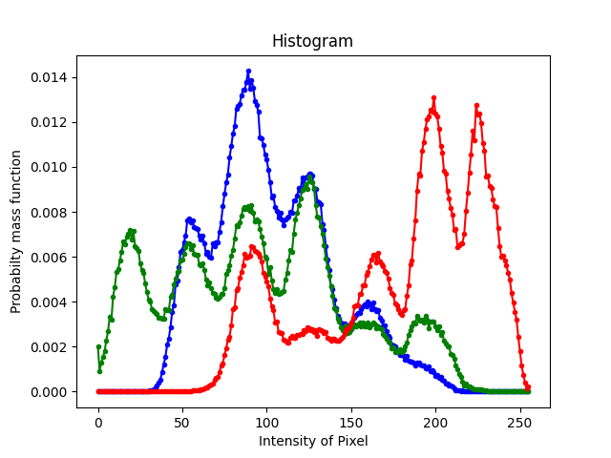

Pseudo Code:
Algorithm FloydSteinberg(img,k)
if k==0
color=dither(img.color)
for 0<=i<row
for 0<=j<column
Page 3
img[i][j]=color return
else
index=exausSearch(img.color) //return index of min error
FloydSteinberg(img[:index],k-1)
FloydSteinberg(img[index:],k-1)
end

Time Complexity:
O(n^2*log(n)

Lenna img with 4 colors
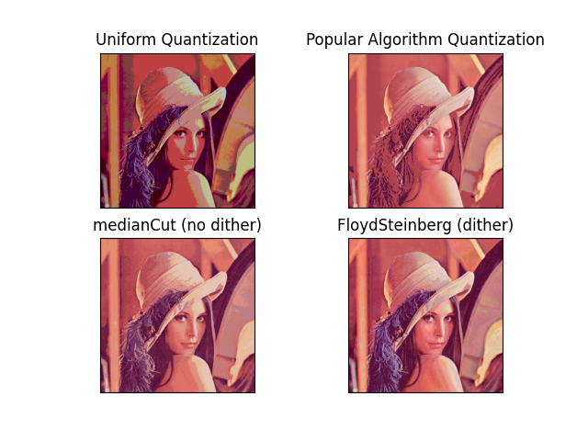

Lenna img with 16 colors
Page 4
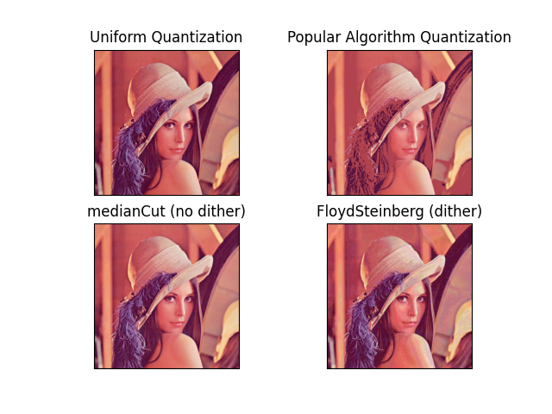

Lenna img with 32 colors
Page 5
Page 5
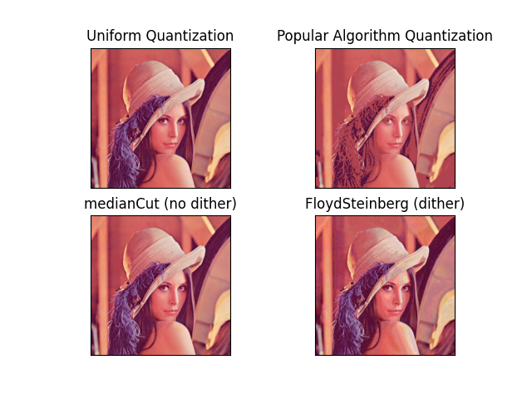
some more example:
apple image with 4 colors:
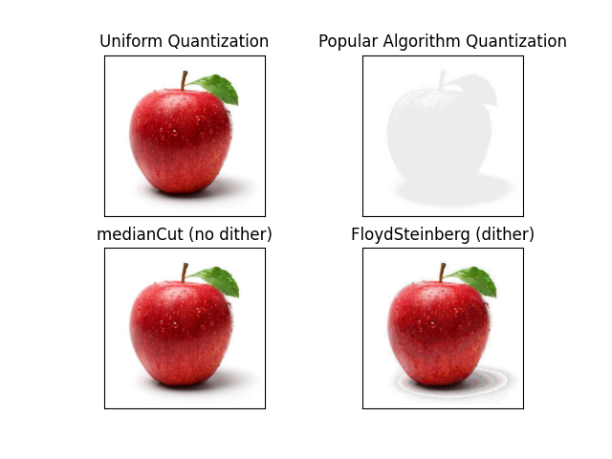
Page 6
apple image with 32 colors:apple image with 64 colors:
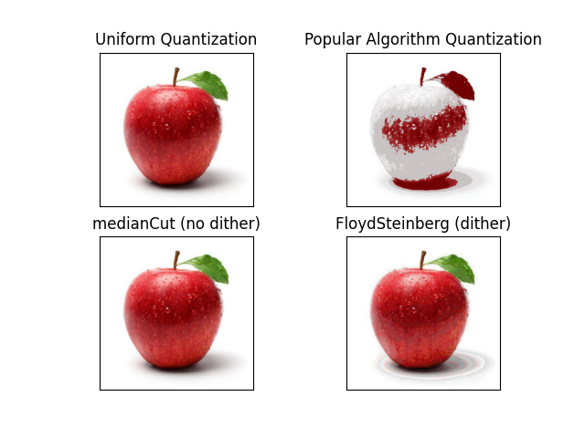
References:

https://www.cse.iitd.ac.in/~pkalra/col783/assignment1/p297-heckbert.pdf

Page 7
Part 2

In the first part of this assignment, we have to colorize the image by using following algorithm.
*Global Image Matching
*Usage of Swatches (interaction of user)

Demo Image:
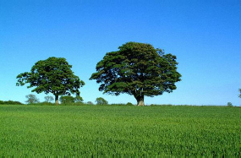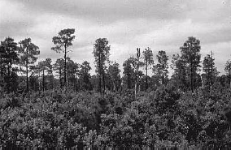
(284*185*3) (285*184*3)

Global Image Matching:
- We have at first used Global Image Matching process. In this, at first we have converted both the source(color) image and target(gray) image into Lab color space where L = intensity and a and b are the color components.
- After converting the images into Lab color space, we have added padding to both the images so that convolution or average can be taken easily.
- Then, we take the color image and select a subset of pixels by using jittered sampling.
- Once a sample is selected, we take a random pixel from that sample and take a 5*5 neighborhood statistics and take the average pixel intensity and save that intensity to form a color map. This color map also contains the color of the random pixel selected. Continuing this for all the samples, a color map is formed.
- Now, we traversed the target image in scan line order and choose the pixel intensity and here also a convolution of 5*5 mask is done so that the corresponding pixel intensity is matched perfectly.
- Once we get the intensity which is the average of 5*5 mask intensity for the corresponding pixel, we choose the closes intensity pixel from the color map and assign the colors of the color map to the selected pixel.
- Continuing for all the pixel, we have colorized the images.

Pseudo Code:

Algorithm form_color_map():
Traverse the color image by selecting a sample.
Select a random pixel from the sampel pixel
row = np.random.randint(x,y)
col = np.random.randint(x,y)
mask = np.array([[1,1,1,1,1],[1,1,1,1,1],[1,1,1,1,1],[1,1,1,1,1],[1,1,1,1,1]])
convolve the random pixel neighborhood
intensi = (np.sum(np.multiply(padded_orig_img[row-2:row+3,col- 2:col+3,0],mask))/25).astype(int)
color_map = []
make a color map for all the sample

Algorithm colorizeImage():
Traverse the gray image pixel by pixel
Again take the average intensity of 5*5 mask
Find the closest intensity in the color map
Assign the color from the color map to the specified pixel
#color image is formed

Images of the Result:

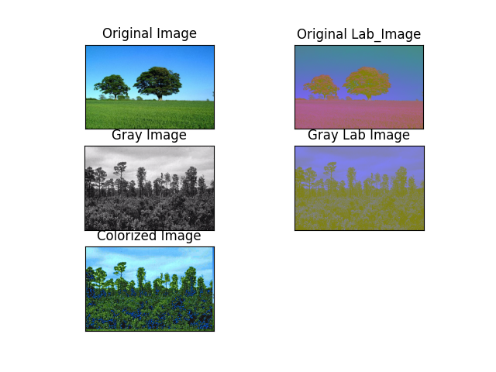

Final Colorized Image:

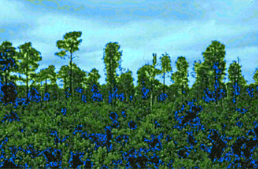

Color transfer using Swatches:

- At first, user selected a swatch from the color image (color swatch) and the corresponding swatch (gray swatch) for the gray image.
- Then, we have divided the color swatch into 50 samples and select a random pixel from the selected sample.
- Then, we have convolved the pixel intensity by a 5*5 mask and make a color map for all the samples selected from the color image.
- Then, we moved to the gray swatch and for each pixel select the intensity from the color swatch and again do a convolution of 5*5 mask with its neighborhood and find the average intensity and find the closed luminance value from the target swatch mapping and assign the colors of the gray swatch.
- In this way, if user has selected different swatches then at first the corresponding gray swatches will be colorized first with global image matching procedure.
- After each gray swatch is colorized, we will form a color_gray_map which will save all the luminance values of the colorized gray swatches.
- Then, we move pixel by pixel in the gray scale image. Find the intensity of the given pixel and take the average intensity with a 5*5 mask and find the closest luminance value in the color map. Once it is found, assign the colors from the color map to the specified pixel.

Algorithm:

Input: n swatches of 2 types:
color_swatch, gray_swatch ( a 2d array consisting of starting points(x,y) and end points(x,y))

Psuedo Code:

Padd the original image for taking convolution
color_map = [] # a color map to assign the intensity and color values of the color swatch
no_of_samples = 50
sample_size = np.sqrt((m*n)/no_of_samples).astype(int)
mask = np.ones((5,5)) # a mask of size 5 for convolution
#----------forming a color map of 50 samples by taking a random pixel and did neighborhood stats on the random pixel----------------------------------------------
i = color_swatch[0][0] # starting point of the color swatch
j = color_swatch[0][1] # end point of the color swatch
while(i<color_swatch[1][0]):
j = color_swatch[0][1]
while(j<color_swatch[1][1]):
row = np.random.randint(i,i+sample_size) # selecting a random pixel for the row

col = np.random.randint(j,j+sample_size) # selecting a random pixel for the column

intensity = (np.sum(np.multiply(padded_orig_img[row-2:row+3,col-2:col+3,0],mask))/25).astype(int)

color_map.append([intensity,orig_img[row][col][0],orig_img[row][col][1], orig_img[row][col][2]])

j = j+sample_size # this ensures that I am taking 50 samples by skipping the sample_size pixels
i = i+sample_size

Now, color map is formed

def find(intensity,color_map):
index = -1;
dist = sys.maxsize
for i,rows in enumerate(color_map):
if(dist>=np.absolute(intensity-rows[0])):
dist = np.absolute(intensity-rows[0])
index = i;
return index

def find(intensity,gray_color_map):
index = -1;
dist = sys.maxsize
for i,rows in enumerate(gray_color_map):
if(dist>=np.absolute(intensity-rows[0])):
dist = np.absolute(intensity-rows[0])
index = i;
return index

def colorize_gray_swatch():
i = gray_swatch[0][0]
j = gray_swatch[0][1]
while(i<gray_swatch[1][0]):
j = gray_swatch[0][1]
while(j<gray_swatch[1][1]):
intensity = (np.sum(np.multiply(gray_img[i-2:i+3,j-2:j+3,0],mask))/25).astype(int) # take the average of neighborhood intensity by taking a 5*5 mask
index = find(intensity, colormap) # returns an index from the color map which intensity values is closest to the calculated intensity

Once all the corresponding swatches is colorized by the above algorithm, we will form a gray_color_map which is the luminance values of all the colorized swatches of the gray scale images.

Now,

def form_colorized_image():
for i, rows in enumerate(gray_img):
for j,pixel in enumerate(rows):
intensity = pixel[0]
intensity = (np.sum(np.multiply(gray_img[i-2:i+3,j-2:j+3,0],mask))/25).astype(int) # take the average of neighborhood intensity by taking a 5*5 mask
index = find(intensity,gray_color_map)
gray_img[i][j][0] = gray_color_map[index][0]
gray_img[i][j][1] = gray_color_map[index][1]
gray_img[i][j][2] = gray_color_map[index][2]

Now, the image is colorized.

